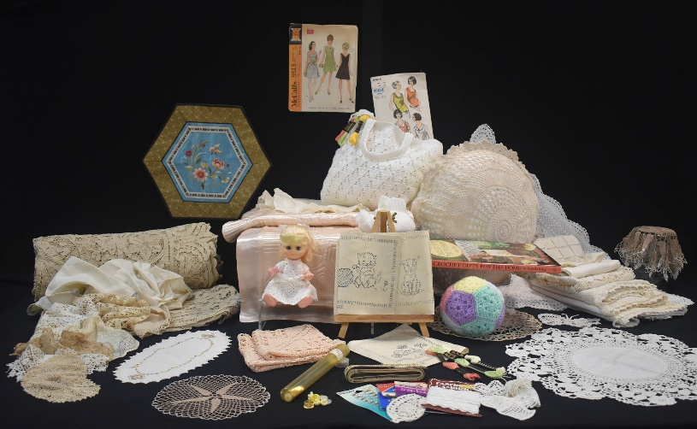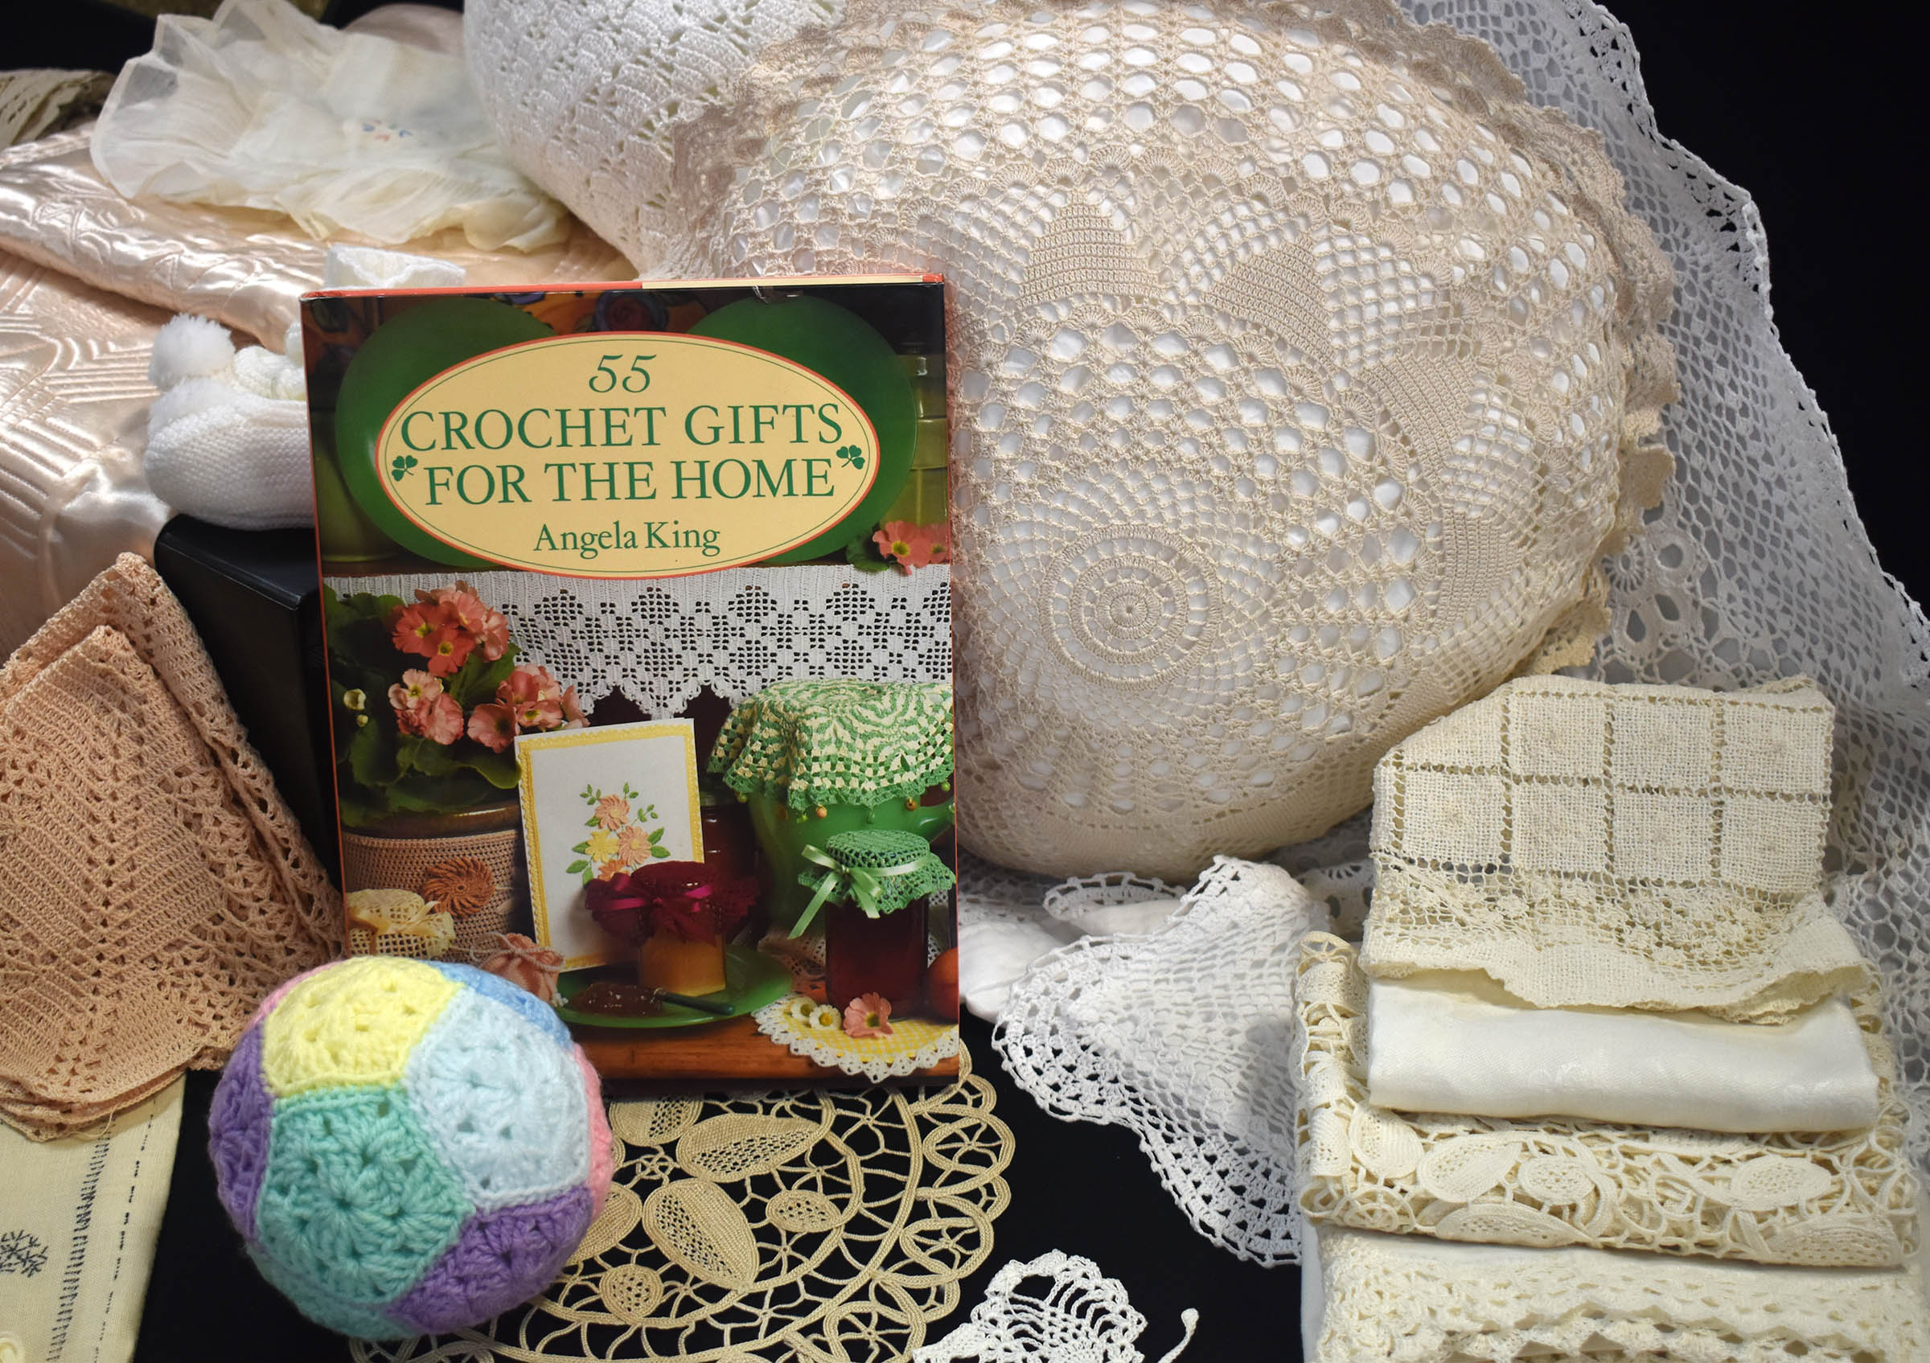

ISTOR

H

Y

WEST

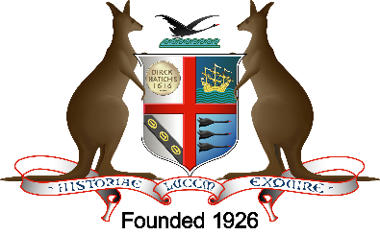

THE ROYAL WESTERN AUSTRALIAN HISTORICAL SOCIETY INC

**Fundraiser Event**

**Vintage Textile sale**

**Sat 16th November, 9.30am – 3pm**

**at the Society, 49 Broadway, Nedlands**

Due to a very large donation of one family’s textile treasures we are having a rare vintage textile sale.  We have an eyewatering range of vintage hand-made items on offer for those looking for an early Christmas gift.   Many items are pristine and unused.  Some of these were lovingly hand-made by the donor’s mother and others are commercial hand-made household linen purchased but never used.  There is also a range of used vintage items in good condition.  The creatively inclined, however, will love the voluminous collection of tatty timeworn pre-loved hand-work just begging to be repurposed.

Forage through an eyewatering range of vintage and hand-made textiles, carefully curated by our museum team.

We have an abundance of unused hand crocheted doyleys, Battenburg lace pillowcases, linen and lace duchess sets, cutwork guest towels, vintage embroidered doyleys, mid and late 20th century dress patterns, haberdashery, babies’ clothes, dolls, babies’ blankets, aprons, crocheted cushion covers, vintage knitting and crochet pattern books, craft books,  We also have a collection of crocheted shawls that would make a perfect gift for an elderly relative or friend.  All funds raised will go towards our planned move to a new premises.  Come along, grab a bargain and support the Society’s future.

