History in the City

Wednesday 3 December 2025

Citiplace Community Centre, Perth Railway Station concourse,

Conference Room, 2:00 pm

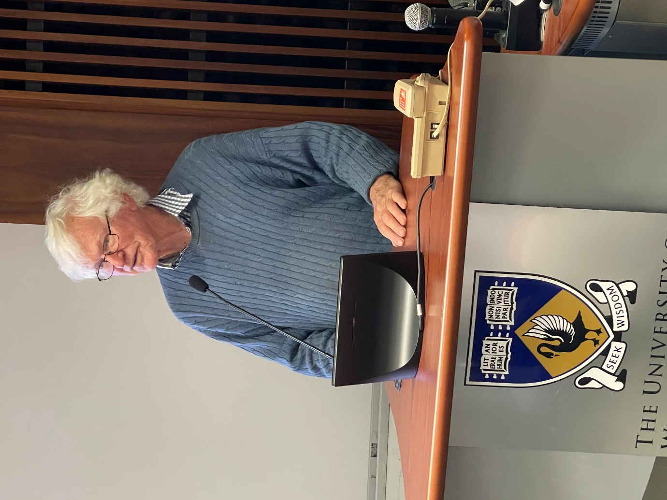
Alex George: Swanning around Perth
From the time 17th Century Dutch seamen became the first Europeans to see Black Swans on the river and called it the ‘Swane Rivier’, the bird has been synonymous with the area now known as Perth, the capital of Western Australia. Adopted soon after settlement in 1829 as a symbol for the Colony (later State), Black Swans have appeared in many forms in coats of arms, crests, sporting and business logos, sculptures, and other forms of artistic expression. In this talk, Alex George will illustrate and discuss many examples of the Black Swan that can be seen around central Perth.
Alex George is a retired botanist who spent his first 15 years living near Alfred Cove, observing the Black Swans on the Swan River, and realising their symbolism for Western Australia. The swans eventually inspired the writing of a co-authored book, Swanning around Perth: An Exploration of the Black Swan in our City, published in 2014.

